Quick reference guide
The Thermal 360 gun must be used in a controlled environment, please make sure you fully read the instruction manual before use.
The achieve optimal performance for checking body temperature we recommend is mounted on the tripod stand in a controlled environment.
You must check the location where you intend to use it for high heat sources such as PC/laptops, Radiators/heaters, windows with strong sunlight, power cables and mobile phones.
The device will not turn on with the USB / power cord connected. Once tuned on do not keep turning it on /off in quick succession as it can damage the device.
Please set the device up in the location you intend to use it, turn on the power and leave it to adjust to the room temperature for 15minutes.
For best results, the room temperate must be between 20degrees and 30degrees with all high heat sources removed.
We recommend setting the device to thermal mode to check the area for high heat sources and where possible remove them, place a heat resistance screen in front or change the location. When a high heat sources is detected by the device it will display a red triangle with a H in the middle. If this happens switch of the device and let it cool down for 10 minutes.
To test body heat:
- Make sure the battery is fully charged and the device is left for 15 minutes to cool down once unplugged.
- You have set the device up in a suitable location without high heat sources.
- You have set the correct max and min temperature.
- You have set the auto power off.
- If connecting to a PC you have set the USB mode.
- You have loaded the PC software.
- You have set the Auto Save function.
- We recommend you set the Image Mode to digital.
- That you
- That a line is marked on the floor 1m and 2m away from the device to create a corridor.
- The laptop/PC should be located 1m away from the tripod to keep within the social distancing rule and would be monitored by security or a member of staff.
Each customer must decide how to deal with each abnormal temperature alarm.
When used as a standalone handheld device, the LED flashlights starts flashing to warn of an abnormal temperature, please do not point the flashlights at people or animals. When connected to a PC/Laptop with speakers the PC/Laptop alarms as well as the LED flashlight flashing.
To capture pictures when used as a standalone handheld device you will need to purchase an SDcard
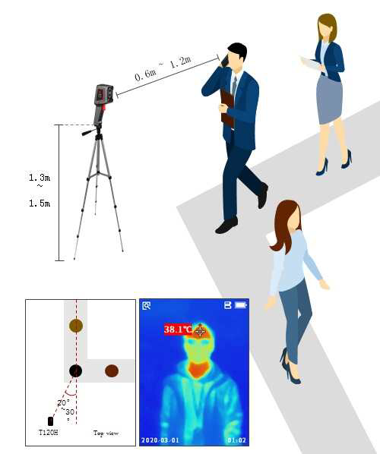
Thermal 360

